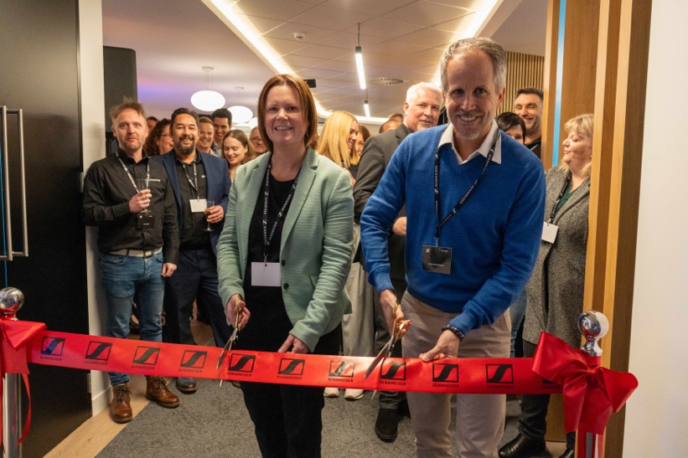
Cutting the ribbon: Kelly Watts, Director of Operations UK & Nordics and Andreas Sennheiser, co-CEO at Sennheiser

Sennheiser UK unveils new Marlow home
The new office provides ample space for the team and offers multiple demo facilities for Sennheiser Group innovations

Wedemark, November XX, 2023. Sennheiser UK has recently unveiled its new office in Marlow, a space thoughtfully designed to embrace innovation while providing ample room for the Sennheiser team to thrive. This facility not only caters to the team’s needs, but doubles as a vibrant showcase for the latest advancements in audio technology from the Sennheiser Group.

The end of November saw the new facility officially opened by Sennheiser’s co-CEO, Andreas Sennheiser, and Kelly Watts, Director of Operations UK & Nordics, with the Sennheiser UK team and invited guests participating in one of three simultaneous tours of the new premises. Information was provided via Sennheiser’s MobileConnect Wi-Fi-based assistive listening solution, giving attendees the freedom to explore the facility at their own pace.

Following the tour, visitors had the opportunity to get first hand experience of the latest audio solutions showcased in the Neumann Studio, featuring Neumann KH monitors alongside Merging Technologies' Anubis multifunctional audio tool. Additionally, visitors could experience Neumann’s NDH 20 and NDH 30 headphones, connected to the new MT 48 audio interface, all on display.

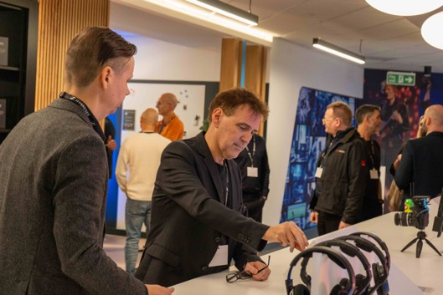 | At the inaugural event, visitors were invited to experience the latest solutions from Sennheiser, Neumann, Merging Technologies, and DearReality

The product demo table served as a focal point, highlighting the Evolution Wireless Digital family alongside the cutting-edge Digital 6000 wireless system. Complementing this were Sennheiser’s full range of professional audio headphones, including an exciting glimpse of an up-coming product.

“We are incredibly excited about Sennheiser UK’s new facilities in Marlow,” says Kelly Watts. “Located just a stone’s throw away from Marlow’s charming cafes and restaurants, the site is conveniently accessible by car or public transport. We believe this space is an environment that ignites creativity and encourages collaboration, benefiting both our team and our customers.”

The new Sennheiser UK facility not only caters to the team’s needs, but doubles as a vibrant showcase for the latest advancements in audio technology | 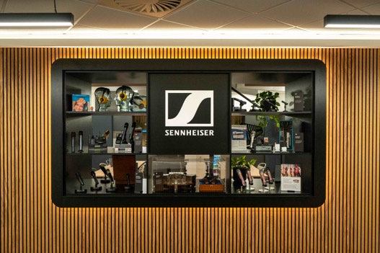

About the Sennheiser Group

Building the future of audio and creating unique sound experiences for our customers - this is the aspiration that unites the employees of the Sennheiser Group worldwide. The independent family-owned company Sennheiser was founded in 1945. Today, it is managed in the third generation by Dr. Andreas Sennheiser and Daniel Sennheiser and is one of the leading manufacturers in the field of professional audio technology.

sennheiser.com | neumann.com | dear-reality.com | merging.com

Local Press Contact
Sennheiser electronic GmbH & Co. KG
Maik Robbe
Communications Manager EMEA
T +49 (0) 5130 / 600 1028
Maik.Robbe@sennheiser.com

